Problem 1: is open_round being considered as general open behaviour? FIXED
OTHER ISSUE: if mouse enters open arm in beginning of session, is it counted? It does not, it is not really a transition anyway – Update, I want to use only instances where I am sure there was a transition, so fine to exclude this FIXED

Using the code below, adjusting which are the main behaviours, setting both O_prevC, and o_round in the main or prev behaviours allow both to be used
main_behaviors = [
"in zone(o1_prevc1 / nose-point)",
"in zone(o2_prevc2 / nose-point)",
'In Zone(o1_round / nose-point)',
'In Zone(o2_round / nose-point)'
]

prev_behaviors = [
"in zone(c1_prevo1 / nose-point)",
"in zone(c2_prevo2 / nose-point)"
]
gives
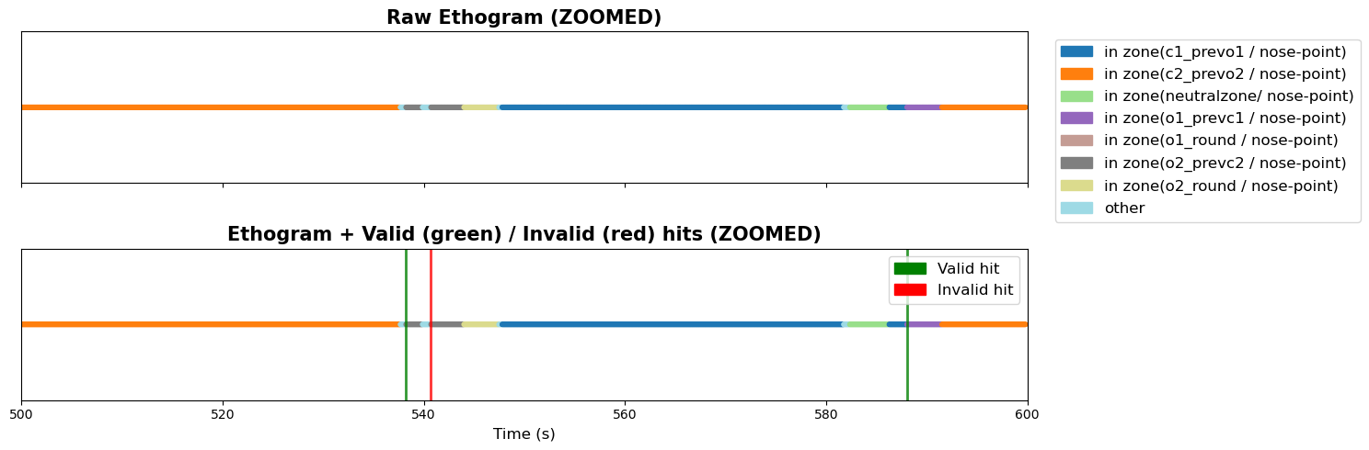
While
main_behaviors = [
# "in zone(o1_prevc1 / nose-point)",
# "in zone(o2_prevc2 / nose-point)",
'In Zone(o1_round / nose-point)',
'In Zone(o2_round / nose-point)'
]

prev_behaviors = [
"in zone(c1_prevo1 / nose-point)",
"in zone(c2_prevo2 / nose-point)"
]
Gives
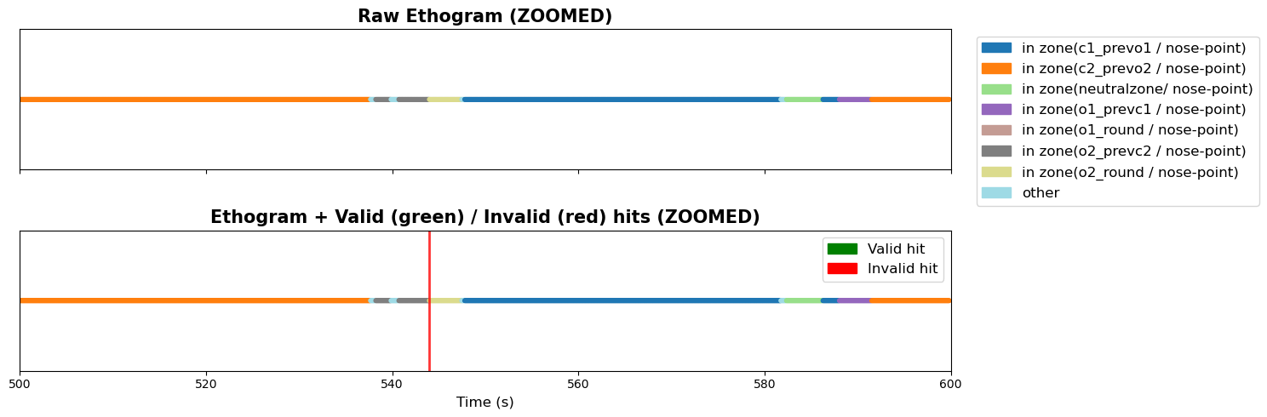
So O_round is detected. But if it comes after O_prev, it does not count as a new instance

❗ Your question:
if one main_behavior follows another main_behavior, does it create a hit?
Example:
o1_round → o2_prevc2
or
o1_prevc1 → o2_round

🚨 CASE 1: continuous main → main transition
Example:
o1_round → o2_prevc2

What happens:
- o1_round → is_main = 1
- o2_prevc2 → is_main = 1
So:
1 → 1

❌ Result: NO HIT
Because your detector only triggers on:
0 → 1
NOT:
1 → 1

🚨 CASE 2: leaving main then re-entering
Example:
o1_round → neutral → o2_prevc2

Timeline:
step | is_main
o1_round | 1
neutral | 0
o2_prevc2 | 1

✅ Result: YES HIT
Because:
0 → 1 transition happens again
So this becomes a new hit.

🧠 KEY RULE (very important)

A hit is NOT:
- switching between main behaviors

A hit IS:
- entering ANY main behavior AFTER being outside all main behaviors

Checked with the code below
import re
import numpy as np
import matplotlib.pyplot as plt
import matplotlib.patches as mpatches

# ==========================================================
# NORMALIZATION (MATCHES PERI-EVENT STYLE)
# ==========================================================
def norm(s):
return re.sub(r"\s+", " ", str(s)).strip().lower()

def is_neutral(s):
return "neutralzone" in norm(s)

def is_other(s):
return norm(s) == "other"

# ==========================================================
# PRECEDING LOGIC (UPDATED: SKIP neutral + other like peri-event fix)
# ==========================================================
def valid_preceding_behavior(behaviors, idx, prev_behaviors):

if idx <= 0:
return False

prev_set = set(map(norm, prev_behaviors))

i = idx - 1

# walk backwards until we find meaningful behavior
while i >= 0:
b = behaviors[i]
nb = norm(b)

# SKIP non-informative states (KEY FIX)
if is_neutral(nb) or is_other(nb):
i -= 1
continue

# first meaningful behavior decides validity
return nb in prev_set

return False

# ==========================================================
# PICK ONE TRIAL
# ==========================================================
trial_key = list(combined_trials.keys())[1]
trial_data = combined_trials[trial_key]

behaviors = np.array(trial_data["Behavior"].values)
time_vec = np.array(trial_data["Time_video"].values)

# ==========================================================
# NORMALISE BEHAVIOURS
# ==========================================================
behaviors = np.array([norm(b) for b in behaviors])

# ==========================================================
# DEFINE BEHAVIOURS
# ==========================================================
main_behaviors = [
'In Zone(o1_prevc1 / nose-point)',
'In Zone(o2_prevc2 / nose-point)',
'In Zone(o1_round / nose-point)',
'In Zone(o2_round / nose-point)'
]

prev_behaviors = [
'In Zone(c1_prevo1 / nose-point)',
'In Zone(c2_prevo2 / nose-point)'
]

main_behaviors = set(map(norm, main_behaviors))
prev_behaviors = list(map(norm, prev_behaviors))

# ==========================================================
# BOUT DETECTION (UNCHANGED STRUCTURE, FIXED LOGIC ONLY)
# ==========================================================
is_main = np.array([b in main_behaviors for b in behaviors]).astype(int)

starts = np.where(np.diff(np.r_[0, is_main]) == 1)[0]

valid_hits = [
i for i in starts
if valid_preceding_behavior(behaviors, i, prev_behaviors)
]

invalid_hits = [i for i in starts if i not in valid_hits]

# ==========================================================
# COLOR MAP
# ==========================================================
unique_behaviors = np.unique(behaviors)
colors = plt.cm.tab20(np.linspace(0, 1, len(unique_behaviors)))
color_map = dict(zip(unique_behaviors, colors))
color_array = [color_map[b] for b in behaviors]

# ==========================================================
# ZOOM WINDOW
# ==========================================================
t_start = 500
t_end = 600

mask = (time_vec >= t_start) & (time_vec <= t_end)

time_vec_z = time_vec[mask]
behaviors_z = behaviors[mask]
color_array_z = [color_map[b] for b in behaviors_z]

valid_hits_z = [v for v in valid_hits if t_start <= time_vec[v] <= t_end]
invalid_hits_z = [v for v in invalid_hits if t_start <= time_vec[v] <= t_end]

# ==========================================================
# FIGURE (UNCHANGED VISUAL OUTPUT)
# ==========================================================
fig, (ax1, ax2) = plt.subplots(2, 1, figsize=(15, 5), sharex=True)

# RAW ETHOGRAM
ax1.scatter(time_vec_z, np.ones_like(time_vec_z),
c=color_array_z, s=10)
ax1.set_yticks([])
ax1.set_title("Raw Ethogram (ZOOMED)")

# ETHOGRAM + HITS
ax2.scatter(time_vec_z, np.ones_like(time_vec_z),
c=color_array_z, s=10)

for v in valid_hits_z:
ax2.axvline(time_vec[v], color="green", lw=2, alpha=0.8)

for v in invalid_hits_z:
ax2.axvline(time_vec[v], color="red", lw=2, alpha=0.8)

ax2.set_yticks([])
ax2.set_title("Ethogram + Valid (green) / Invalid (red) hits (ZOOMED)")

# LEGENDS
patches = [mpatches.Patch(color=color_map[b], label=b) for b in unique_behaviors]
ax1.legend(handles=patches, bbox_to_anchor=(1.02, 1), loc="upper left")

hit_legend = [
mpatches.Patch(color="green", label="Valid hit"),
mpatches.Patch(color="red", label="Invalid hit")
]
ax2.legend(handles=hit_legend, loc="upper right")

ax2.set_xlabel("Time (s)")
ax1.set_xlim(t_start, t_end)

plt.tight_layout()
plt.show()

20260606
Using what is currently in the code + using only normal open zones, not round in defining valid behaviours
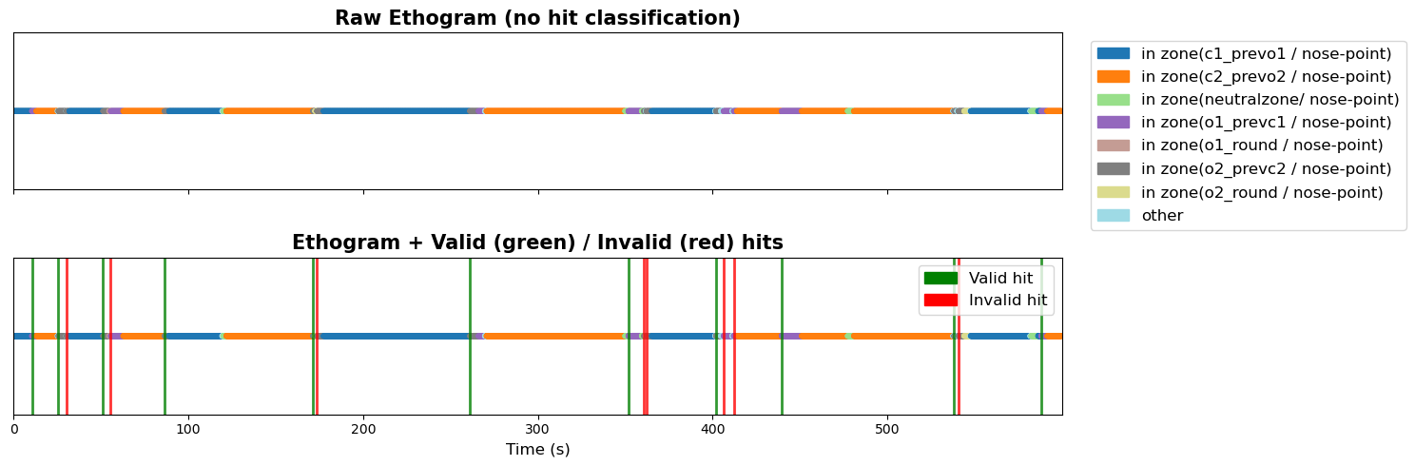
Zoom in
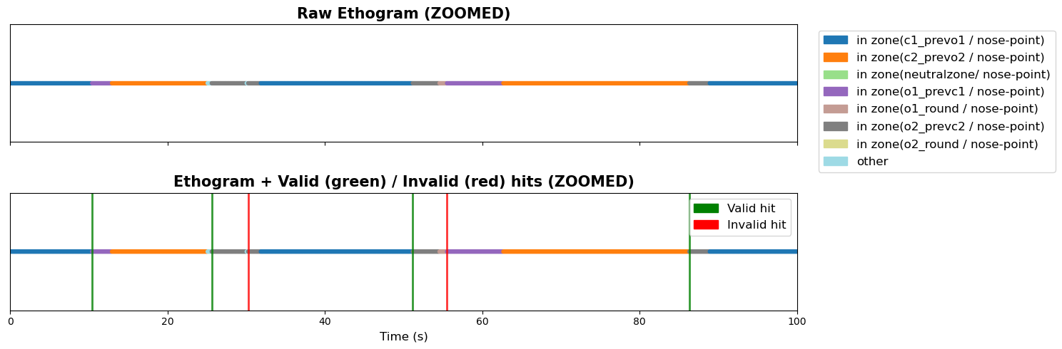
With round zones in definition
main_behaviors = [h
"in zone(o1_prevc1 / nose-point)",
"in zone(o2_prevc2 / nose-point)",
'In Zone(o1_round / nose-point)',
'In Zone(o2_round / nose-point)'
]

prev_behaviors = [
"in zone(c1_prevo1 / nose-point)",
"in zone(c2_prevo2 / nose-point)"
]


20260601
With original funfunfunktion skipping neutral/other behaviours
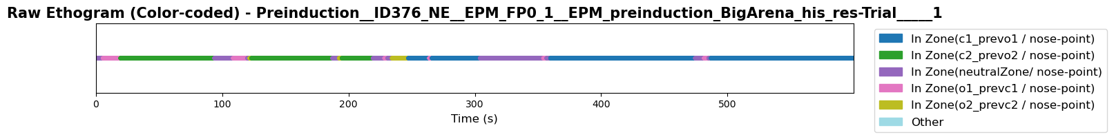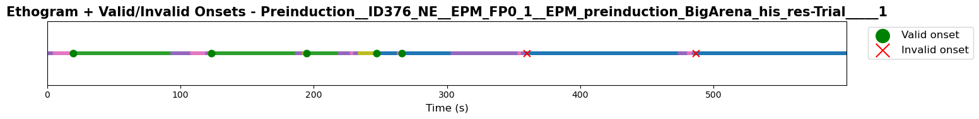

With adapted funfunfunktion skipping neutral/other behaviours based on BOUTS rather than FRAMES

New trial method: but does this use O_round also as open? I think it does NOT consider it in relevant mian behaviour = can be fixed by including ths as well in the main/prev behaviour, not just O_prevC instances of open arms.

Open to closed
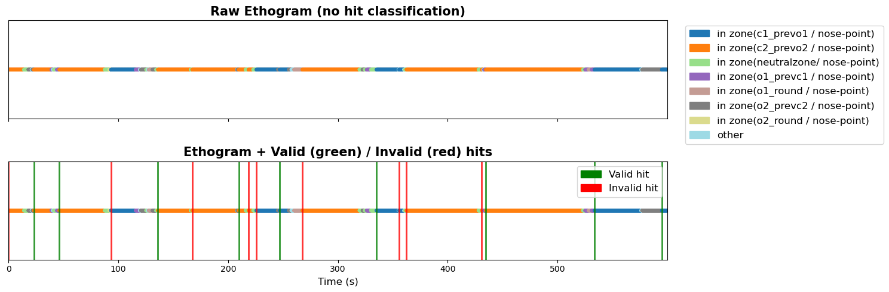

Closed to open
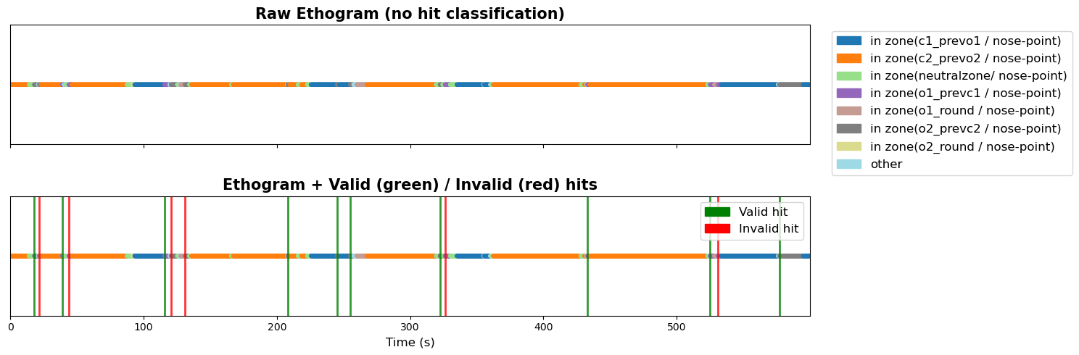

Problem 2: why is “raw trace” in peri event plot showing MUCH lower values than in the mean_dff bar plot? They both use mean dff (this is an example with an old AUC but AUC and mean dff should be similar, and when I run the script where I DO use mean dff it has the same problem

Identified why: peri event plots use baseline subtraction using period of 2 s lading up to event, and subtracts that from the trace. Post event ‘raw’ mean dff does NOT do this subtraction, which is why the vakules look different.
Question remain, for the post event values, is it best to use a subtracted value (if not, then differences in ‘baseline’ could look like real effects?

(base) annastuckert@MCKDQTN4YXDV FP_behaviour_analysis % git commit -m "found issue why trace plots showed lower mean dff than bar plots. it is because trace plots used baseline subtraction from the trace to get all traces into the same 0-centered starting point, so trace deflections were relative to 0. the raw traces (that have undergone preprocessing including dff calæculations, so should be in the same scale relative to one another) have different starting points relative to 0. the bar plots use these raw traces, not the baseline subtracted ones. next step is tto do bar plots both with baseline subtracted and raw traces"
[main 9cf7b1d] found issue why trace plots showed lower mean dff than bar plots. it is because trace plots used baseline subtraction from the trace to get all traces into the same 0-centered starting point, so trace deflections were relative to 0. the raw traces (that have undergone preprocessing including dff calæculations, so should be in the same scale relative to one another) have different starting points relative to 0. the bar plots use these raw traces, not the baseline subtracted ones. next step is tto do bar plots both with baseline subtracted and raw traces

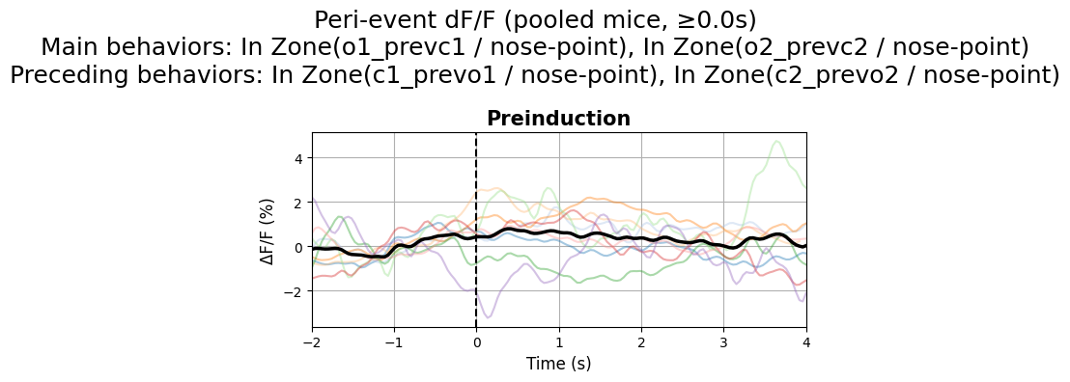
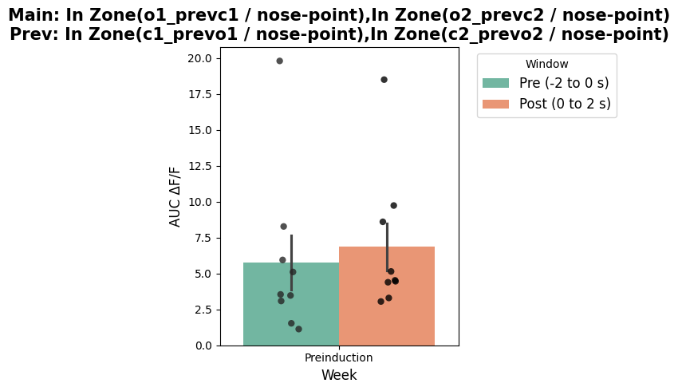

O1 and O2 round not actually also being included in general open arm entries

